Teacher Leader Institute
15-16 September, 2017 Dubai

Leadership Tools for

International Teacher Leaders

Empowering Students

through Assessment

IMPORTANT REMINDER:

YOU MUST BRING A LAPTOP TO YOUR SESSION

LOCATION
Le Meridien Hotel & Conference Center - Dubai
www.lemeridien-dubai.com
Location: Airport Road, Dubai, UAE
Phone: +971-4217-0000
The hotel is 5 minutes from the airport

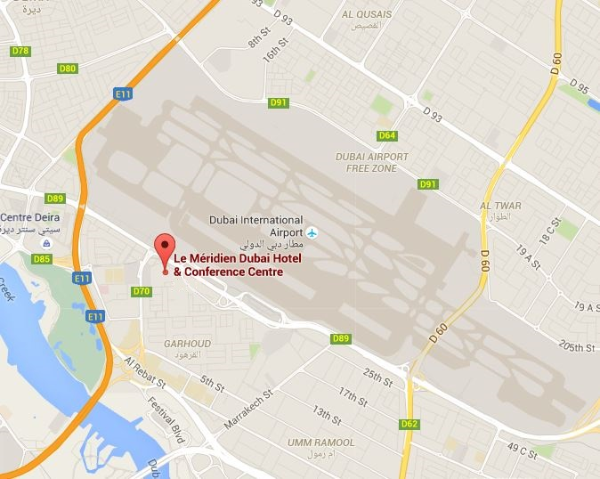
TLI INSTITUTE ARRIVAL

Friday 15 September 2017
- 7:30 – 8:00 am: TLI Institute registration in the hotel will take place outside of the Wasl 1 & 6 rooms. Please arrive in time to pick up your name badge and other institute related material. Bring your laptop so coordinators can ensure you have downloaded your course book.
- 8:00 am: Institute begins. Arrive in plenty of time to attend this first session.

WHAT TO BRING
- Completed preparation assignments
- Laptop computer with wireless internet access; download course materials before your arrive
- An iPad or tablet may also be used instead of a computer. If you do, be sure you have iAnnotate, PDF Expert 5, Notability, Good Reader, or any other app that recognizes links and will allow you to annotate and save a PDF.
- Cord for charging lap top and UAE compatible adaptor if necessary
- Any items required to make your stay more comfortable in the hotel room
- Swim suit and gym clothes if you wish to use recreational facilities
VISAS

Before you travel to the UAE, please check your visa requirements and make sure you have a valid visa if needed. Holders of non-standard passports and travel documents may also have different entry requirements. Check your visa and passport requirements at: http://www.uae-embassy.org/services-resources/visas-passports/non-us-citizens. There are three categories of Visas:
ONE:
Citizens of the GCC nations of Bahrain, Kuwait, Oman, Qatar and Saudi Arabia do not require a visa to travel to the UAE.
TWO:
If your country of nationality appears on the Visa on Arrival list below, no advance visa arrangements are required to visit the UAE. Simply disembark your flight at Dubai International Airport and proceed to Immigration, where your passport will be stamped with a 30-day visit visa free of charge. This can be extended for an additional 30 days at an additional charge.
VISA on ARRIVAL LIST - see countries listed below
See Link http://www.uae-embassy.org/visas-passports/non-us-citizens
Australia  Andorra  Austria  Brunei  Belgium  Canada  Denmark | Finland  France  Germany  Greece  Hong Kong  Iceland  Ireland | Italy  Japan  Liechtenstein  Luxembourg  Malaysia  Monaco  Netherlands | New Zealand  Norway  Portugal  San Marino  Singapore  South Korea  Spain | Sweden  Switzerland  UK  USA  The Vatican

THREE:
VISA IN ADVANCE OF TRAVEL LIST - See Link https://www.dubaivisa.net/EK-OnlineVisa/Countries.aspx
- Your hotel should be happy to help with entry applications and to assist registered hotel guests in obtaining a visa. However, all applications are subject to the Ministry's approval, rules and regulations.
- There are fees and some countries are required to post a refundable deposit – refunded on departure from the UAE.
- The standard Visa is AED 360 (approx. US$105)
- Please secure your visa as soon as you are able to, in order to support a timely visa process.

HOW TO GET THERE

- Taxi from airport costs about $9-$10* (AED 35-40). Perhaps exchange enough for a taxi before leaving the airport.
- Hotel Car service is available for about $14* (AED 50) per one way trip. If you are arriving in a group, it may be beneficial to arrange a van to pick you up. *Currency conversions are approximations

ACCOMMODATION
Here is a list of nearby hotels comprising a wide range of prices and amenities. All are within walking distance of the Le Meridien Hotel. Booking early allows for the best possible rate.
Le Meridien Hotel & Conference Center
Hotel website: www.lemeridien-dubai.com
Location: Airport Road, Dubai, UAE
Hotel Contact: Tel +971 4217 0000
Millennium Airport Hotel Dubai
Hotel website: http://www.millenniumhotels.ae/millenniumdubai/
Location: Casablanca Road, Al Garhoud, Dubai 13018, UAE
Hotel contact: Tel +971 4702 8888
Dubai International Hotel
Hotel website: dubaiintlhotels.com
Location: Dubai International Airport, Transit Area, Near Terminal 1, Dubai, UAE
Hotel contact: Tel +971 4224 4000
Al Bustan Rotana
Hotel website: https://www.rotana.com/rotanahotelandresorts/unitedarabemirates/dubai/albustanrotana
Location: Casablanca Road, Al Garhoud, Dubai, UAE
Hotel contact: Tel +971 4282 0000

DAILY SCHEDULE

Day 1  15 September | • Registration from 7:30 - 8:00 am  • Class from 8:00 am - 5:00 pm
Day 2  16 September | • Class from 8:00 am - 4:00 pm  Most hotels provide a luggage storage facility if you require it.
Note: Participants must complete the full institute in order to receive a certificate of completion. Those who arrive late or
depart early will not receive confirmation of participation.

COURSE MATERIALS
Your course materials are digital and will be available for download via an email prior to the start of your course. No print copies will be available. Internet is free in the meeting rooms, but please keep only ONE device connected to the internet at any one time.
INTERNET ACCESS

The Le Meridien Hotel provides free internet access in hotel public areas and the TLI meeting room. Be sure to have the appropriate UAE adapter plugs for your computer, if necessary, as these are not supplied.

MEDICAL ASSISTANCE
Mediclinic Welcare Hospital: +971 4 282 7788; mediclinic.ae

CANCELLATION POLICY

Full payment due at time of registration.
Cancellation policy: Before 14 August 2017 - $200 of total cost (per course) is NON-REFUNDABLE.
After 14 August 2017 – Course fees are NON-REFUNDABLE.
Note: All refundable fees will be held as CREDITS for the following year unless other arrangements have been made with the PTC.

TLI CONTACT

If you have any questions or need any other assistance, contact the TTC/TLI office: Phone: +1 508 790-1748; Fax: +1 508 232-6006; Email: registrations@ThePTC.org; Address: Principals' Training Center (PTC) 1666 Kennedy Causeway Suite 207, North Bay Village, FL 33141 USA

